Find Post 5860  www.facebook.com/VeteransOfForeignWarPost5860/  EMail: VFWPOST5860@Gmail.com  Website: VFW5860.org (new)  Mail to: PO Box 135 Spearfish, SD 57783  Or  Address: 3102 East Fairgrounds Loop, Spearfish SD 57783 | Please remember to renew your Dues  $35/year or Go Life  Some ways to pay:  Go Online at Http:/ww.vfw.org/ -Mail a check to PO Box 135, Spearfish, SD 57783  -Bring it to a monthly meeting.  OR Never worry about paying dues again: Go Life and the Post will help you with  $100 towards a life membership  Life Membership Prorated Pricing by Age  <30 =$425 61-70=$290  31-40=$410 71-80=$225  41-50=$375 81 & up=$170  51-60=$335 Post pays $100 of these prices

Queen City VFW Post 5860
3102 East Fairgrounds Loop
Spearfish, SD 57783


Our new Webpage VFW5860.org,  it is up, but we are now customizing it.  The VFW rents out our hall for meetings, parties, weddings and/or receptions and Celebrations of Life. Celebrations of Life for Members are Free of Charge.  Membership  Membership is at 102.97%, Congratulations to all who paid their dues on time and to all of our new members who helped us pass our goal of 102%. We have had 12 new life members so far this year and they all took advantage of the $100 0ff a life membership. Your membership helps our voice in Washington keep our benefits that you deserve for fighting for this country. | The Spearfish Honor Guard sets up for the 6th time on Memorial Day. Every Memorial Day the Honor Guard goes to six locations and performs military honors. 1. Buhla Cemetery, 2. Little Dane Church, 3. St Onge Cemetery, 4. Whitewood Cemetery, 5 Rose Hill Cemetery and finishes with the Spearfish Veterans Monument.  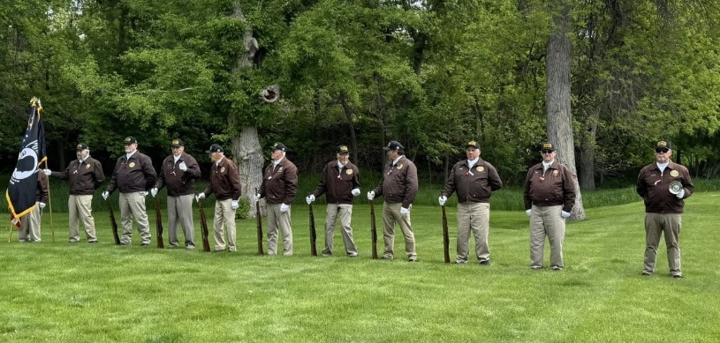

Queen City Post 5860 Newsletter
Where Serving Veterans and Community Doesn’t Get Any Better Than This
Commanders Corner  Hello my fellow Comrades!! Derek Besler here, your Post Commander. May was a busy month for the post, with the Day of Service clean up and Bingo for Food, food drive. Our 1st Annual Post Birthday and Awards dinner. Out of the winner, we had three that won the Department level awards and will receive their recognition at the State Convention in Peirre this June 20th. Memorial Day weekend is always full of events. Starting Thursday with raising the flags on the Avenue of Flags at National Cemetery, then Friday evening placing flags on all the Veterans graves at Rose Hill Cemetery. Sunday members went to place flags at National Cemetery. Monday was the big day where the Honor Guard goes around to six locations in the local area cemeteries to provide military honors and also laying wreath during the Memorial Day Ceremony at the Black Hills National Cemetery. This year one of our own members, General Wyatt Hansen was the guest speaker. He did a great job.  Bingo  EVERY FRIDAY NIGHT  Doors open at 6pm Games at 7pm  All Ages Welcome  Every Friday we have a special meal as well as our pizzas. Along with a full bar and pull tabs.  Youth and Education  The Voice of Democracy and Patriot Pen Themes  VOD: The 2025-26 theme is:  “How Are You Showing Patriotism and Support for Our Country?”  PP: The 2025-26 theme is:  “How Are You Showing Patriotism and Support for Our Country?”  Or go to the website? https://vfw.org/community/youth-and-education/youth-scholarships |  | Still Serving  This year on May 3, 2025 we joined thousands of VFW members across America during the 4rd Annual VFW Day of Service. We completed two projects this year. One was cleaning along side Old Hwy 14 and the other was collecting food and giving away free bingo. Bingo players receive $2 of bingo play for each item up to $10 each Friday during May.  1St Annual Post Birthday and Awards Banquet photos  We would like to Congratulate all of our winners this year. L to R, Cody Clutter on behalf of Spearfish Forest Products-Employer of the Year Dawn Lolly-Dispatcher of the Year, John Bokker-Elementary Teacher of the Year, Aaron Nida-High School Teacher of the Year, Elizabeth Hurley-EMT of the Year, Slater Hambracht-Scout of the Year, Kiminila Featherman-Patriot Pen Winner, Jared Heubrock-1st Place VOD, Elouise Adams-Sierra Ferguson-Received Certificate on behalf of Black Hills Pioneer, 3rd Place VOD, Commander Derek Besler, not pictured Rowan Lutz-2nd Place VOD and Austin Drapeaux Law Enforcement of the Year, Sky Dragoo Firefighter of the year  